Technical solution

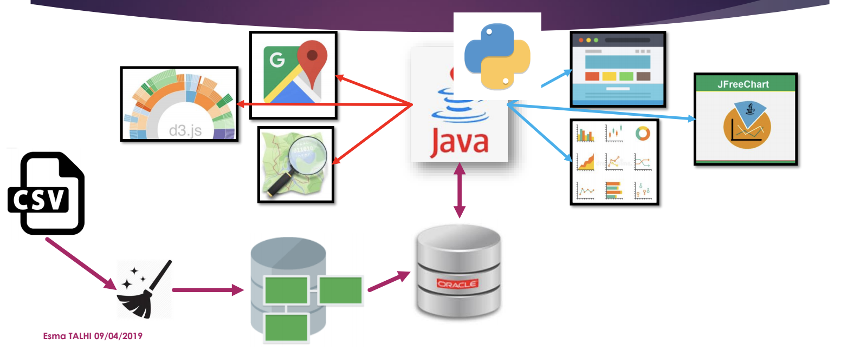

**Description**

There are three major developing software that we use in our project, Python, Oracle SQL and Django.

In the beginning of the research, the raw data is present in Excel file. Then, we import the data to python to do data cleaning and a general data profiling. After, we insert the data to the Oracle SQL. During the developing procedure, we use python again as data analysis software. At last, we choose Django do be our visualizing tool. With Django linking with the Oracle database, our final goal is to present the client dynamically analyzed relation model.

**Introduction of the developing software**

**Oracle SQL**

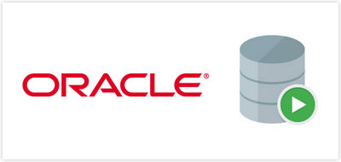

The oracle environment is a database that designated by the clients.

The three major advantages with using oracle SQL developer is that it can manage not only oracle database, but also SQL server and MYSQL, and the second advantage is that it has the cross-platform execution capability with windows, Linux and Mac OX, and the last one is that it is an completely free resource.

**Python**

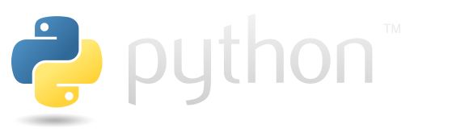

In this project, our team choose python over Java. For the first and the most important reason is that python is the mostly used software in the data science field. The essential of the python is that it simplified the complex coding grammar with fewer lines, and it is an open source that popular in business model. With more and more packages created, python has an comprehend function to analyze data. The the other reason for using python over Java is that python has a great flexibility that can easily connected with the web.

**Django/another?**

**…**

**Google?**